Leeds Shotokan Karate Club – Booking your sessions online

In order to ensure we can limit the numbers for each session all students will have to book their classes in advance. There will be 2 ways to do this, on our website, or through our new mobile application.

To be eligible to book you need to create an account with us

Head to www.leedsshotokan.co.uk and click Log in in the top right of the screen.

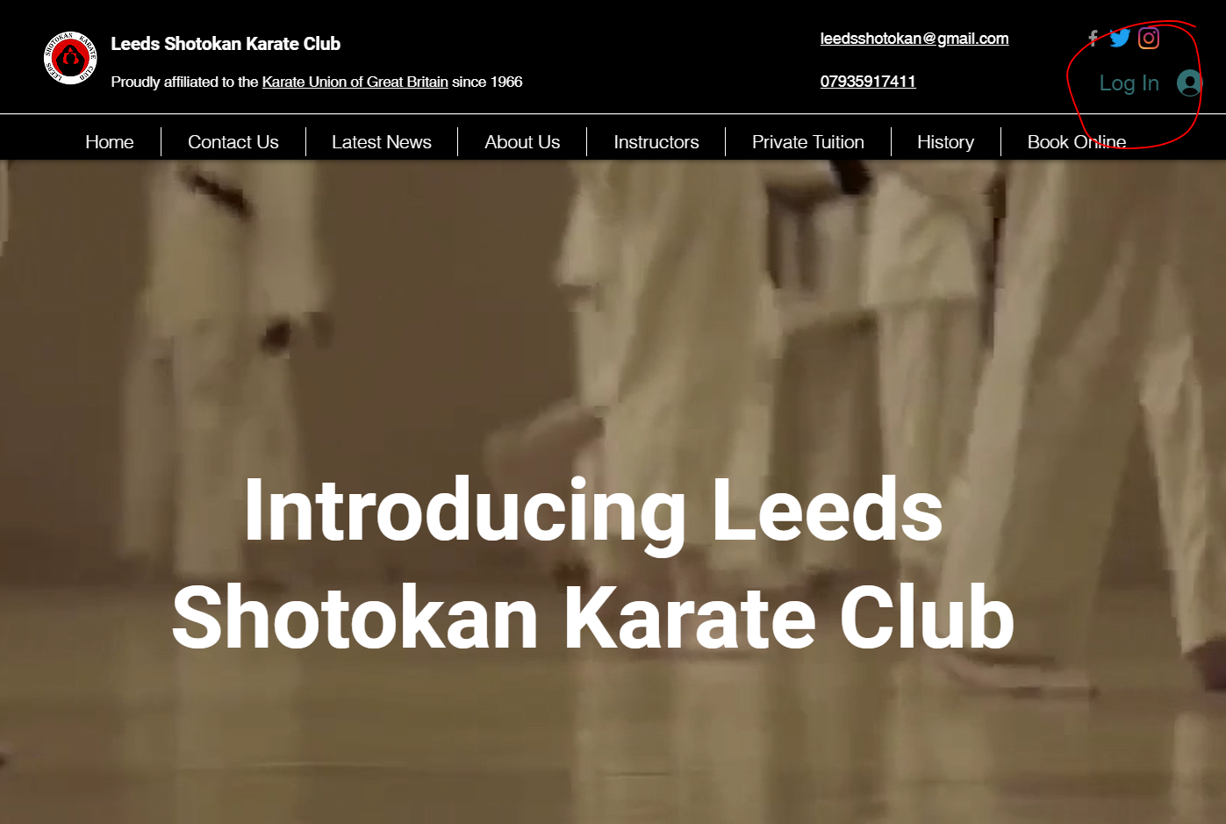

You will be taken to the below page. Where you can enter your email and a password to sign up.

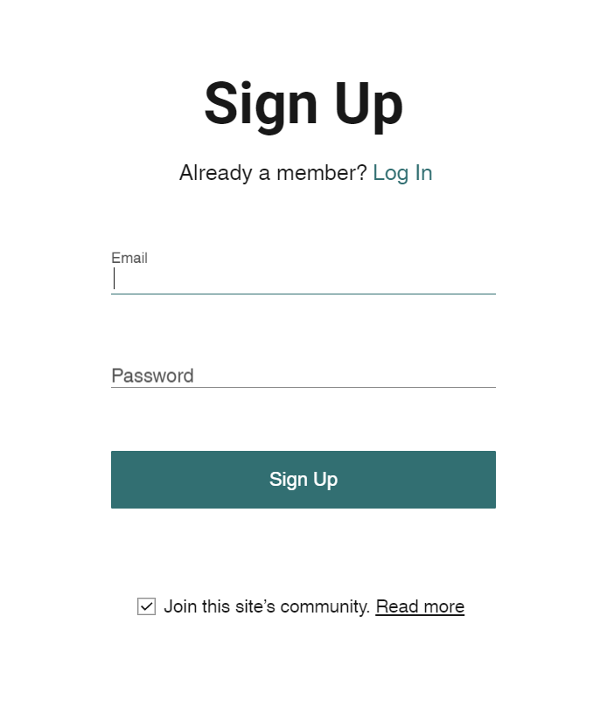

This will send a request to Sensei Ryan to approve, Once approved you will be able to use the “Book Online” tab of the website to sign up for classes.

Please only book classes that you are going to attend. If you need to cancel a booking please email leedsshotokan@gmail.com at least 48 hours before the class. This way we can refund you and offer the slot to another student. We won’t be able to refund you if you are later than this, as another student may have missed out.

Booking through the Leeds Shotokan App

Follow this link to download the Wix Mobile App - http://wix.to/P8CmC_0

Follow the onscreen steps to sign up or sign in!

